## **Hands on: Adding, Moving, Removing Disk Drives**

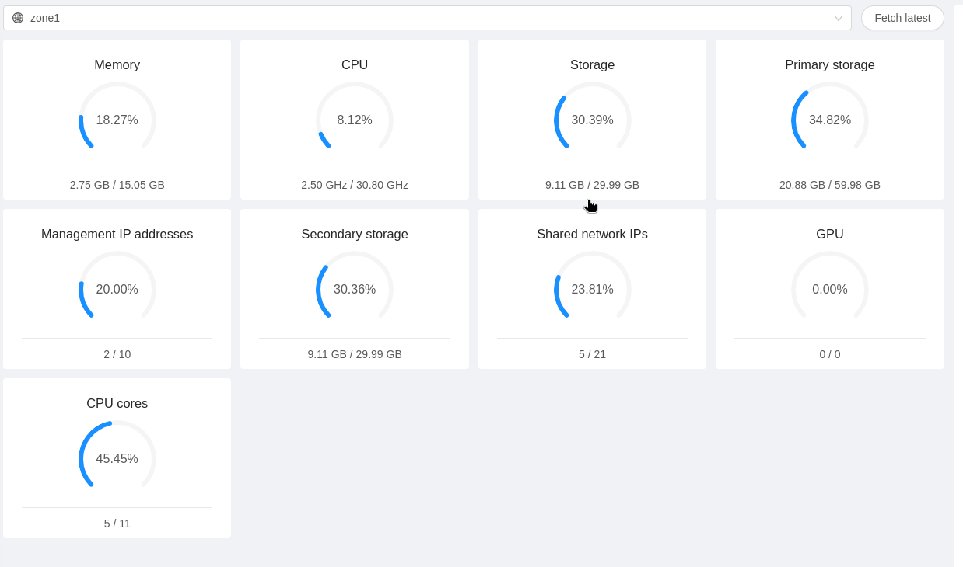Below is a screenshot of my primary storage pool before adding the new nfs drive primary2.

Below is a screenshot of my primary storage after adding the new NFS drive primary 2. Usage has decreased

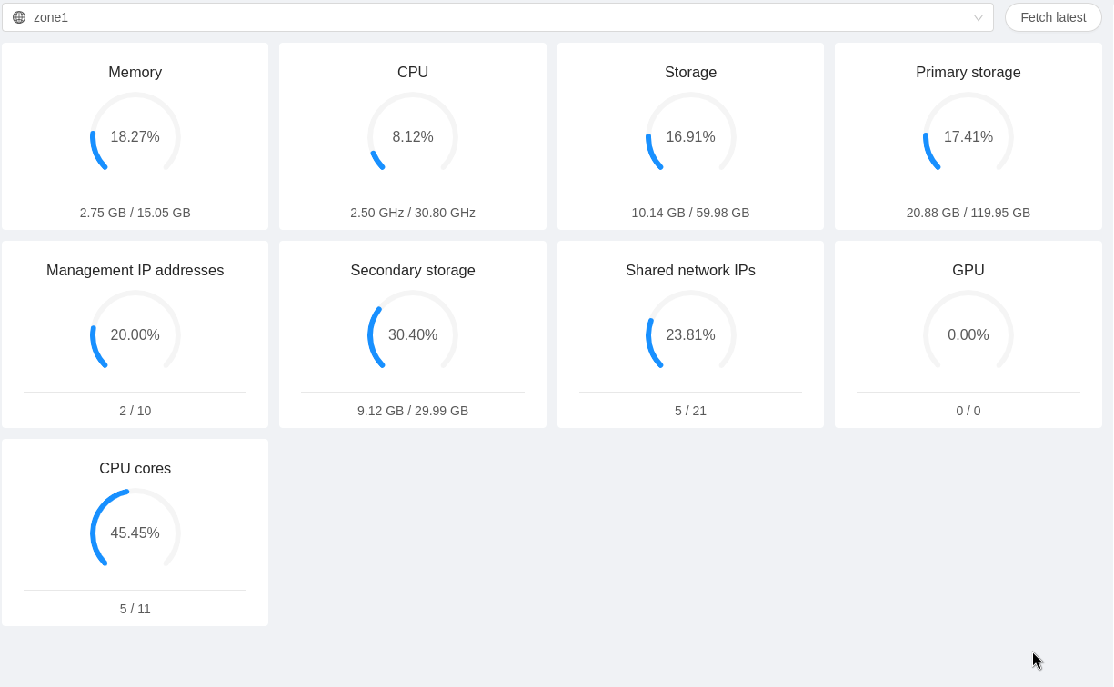

Below is a screenshot of the new storage pool after migrating my VM test3

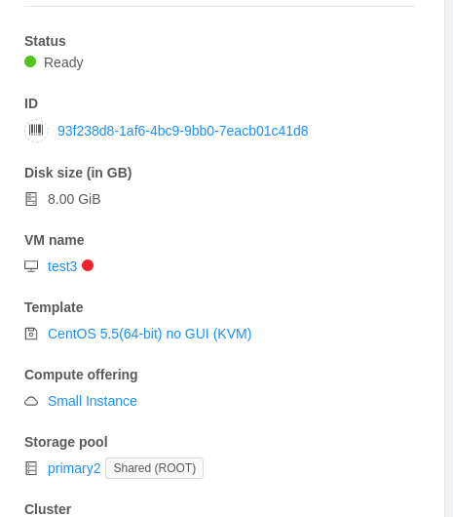

Here is my newly booted VM test3 after migration to primary2

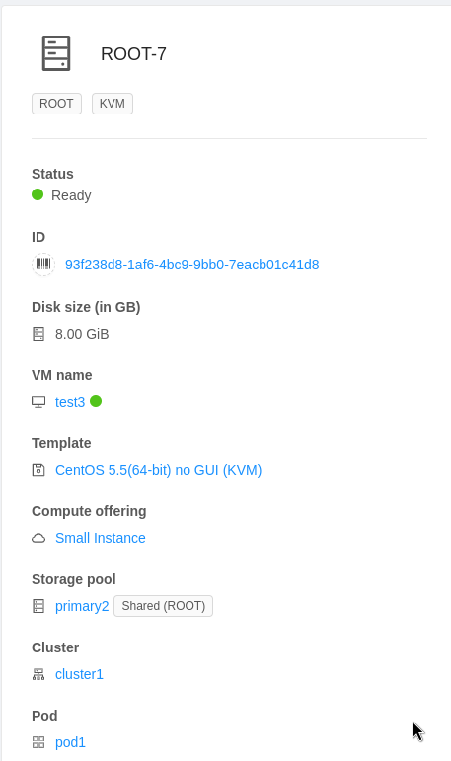

Below is my VM test3 after migrating it to kvmhost1



Below is a screenshot of the remaining volumes on storage disk primary1:

